DK-Technologies Laboratory Journal:
Video timing relations between Black Burst and SD SDI
on DK-Technologies PT5300 and Tektronix SPG 422
2008-06-23 Thomas Holm Hansen

Purpose

The relative video timing between blackburst and SD SDI should be evaluated for two different SPG's. The timing relation should be compared to the ITU recommendation [1] defining the timing between video in the analog and parallel digital domain.

Setup

As opposed to an analog video signal it is not straight-forward to monitor a SDI signal on an oscilloscope since the video is encoded in a scrambled bitstream. Therefore in this test the SD SDI signals are converted to analog to be able to compare the signals on a traditional oscilloscope. The delay through the converter will affect the SDI timing and must therefore be considered.

A block diagram of the test setup is shown below. The SPG under test generates a blackburst signal (Ch 1 on the oscilloscope) and a SD SDI test signal. The SD SDI signal is converted to analog components and the green component is monitored on the oscilloscope (Ch 2).

SPG
(Under test)
Blackburst
SD SDI
Ch 1

Oscilloscope

Ch2
Converter
SD SDI to RGB
Green

The two SPG's to be tested are:

DKT SPG: DK-Technologies PT5300, with option PT8612 quad multiformat SDI test signals. Serial no.: KU030927.
Black burst output: Black 1
SD SDI output: Serial Signal

TEK SPG: Tektronix SPG 422.
Serial no.: B020627.
Black burst output: BB 1
SD SDI output: HD SDI 1

All measurements are done in the 625i / PAL system, and timing on all tested outputs are set to zero.

For converting the SD SDI signal to analog components a DK-Technologies PT5664 waveform montor is used. The delay in the convertion is unknown but from design estimated to be in the order of 1-2 μs. The oscilloscope is an Tektronix TDS3034B

Theory

The timing between analog and digital parallel video signals in the 625i systems are defined in [1]. From the document we get the analog to digital video timing relation as shown in the figure below.

According to this document, the start of active video (SAV at sample 0) should occur 132 luminance samples (9,778μs) after the falling edge of the sync pulse 0_{H}. Furthermore the end of active video (EAV at sample 719) should occur 12 luminance samples before 0_{H} (889ns).

Results

DKT SPG

Vertial alignment
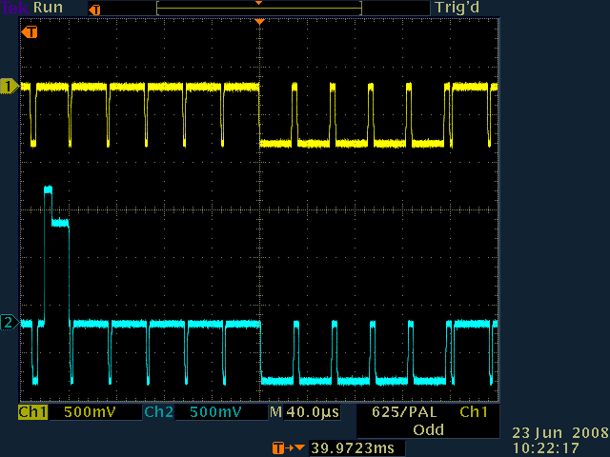

The blackburst and the converted SDI signal aligns vertically.

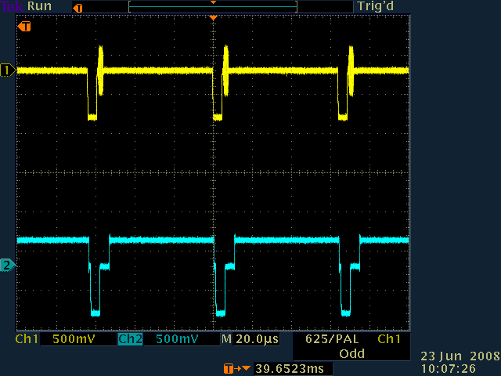
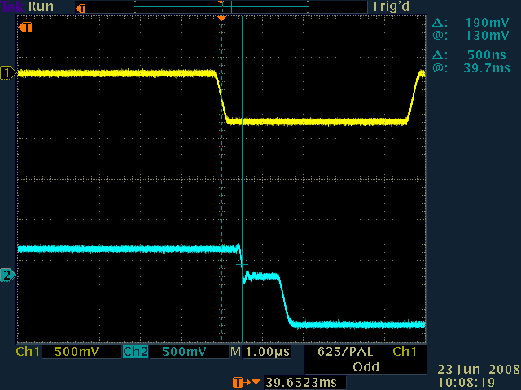
Horizontal alignment

A SD SDI checkfield signal is selected on the SDI output from the SPG. On a checkfield signal the EAV and SAV are easily identified when converted to analog component as a transition from the black level. The position of the EAV is measured on the oscilloscope to 500 ns after 0_{H} in the blackburst. According to [1] the EAV should occur 889ns before 0_{H} but due to delay in the conversion from SD SDI to analog, it is delayed. The difference corresponds to a delay in the converter on 1,389μs, which sounds reasonable.

TEK SPG

Vertial alignment
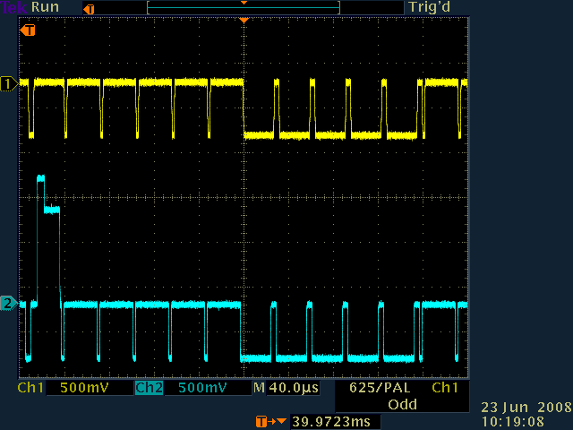
The blackburst and the converted SDI signal aligns vertically.

Horizontal alignment

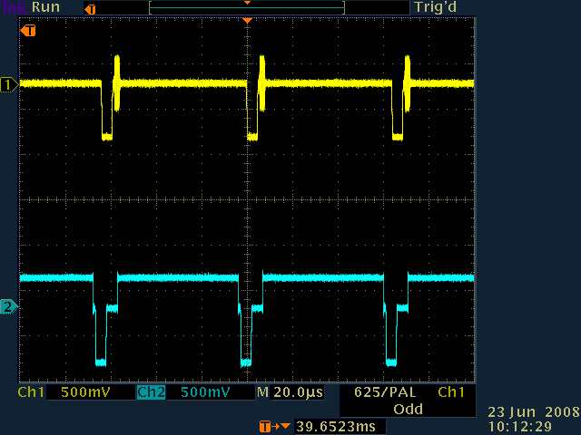
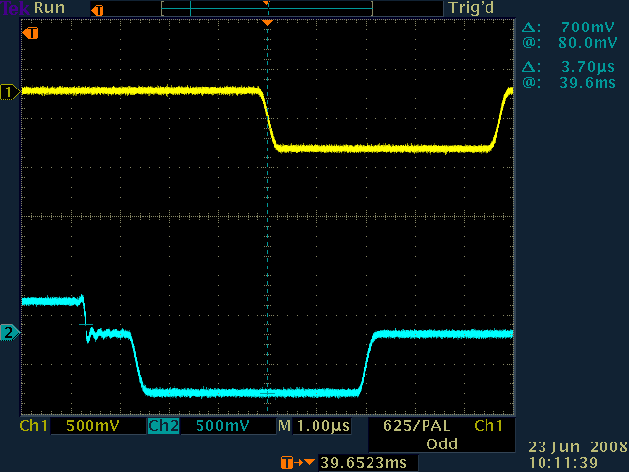
A SD SDI checkfield signal is selected on the SDI output from the SPG. The position of the EAV is measured on the oscilloscope to 3,70 μs before 0_{H} in the blackburst. According to [1] the EAV should occur 889ns before 0_{H}. The measurement shows that the EAV of the SDI signal is too early relative to the blackburst according to [1]. The difference on -2,81μs can not be explained by a delay in the converter since the converter delay is naturally positive.

Conclusion

The timing between blackburst and SD SDI signal was measured on a DK-Technologies PT5300 SPG, and a Tektronix SPG422 SPG, by converting the SDI signal to analog and measure the alignment on an oscilloscope. Since there is an unknown delay in the SDI to analog converter, the timing was not evaluated exactly. The measurements on the DKT SPG indicated that the relative SD SDI timing could be right, assuming a delay in the converter on 1,389μs. Furthermore it is concluded that the relative SD SDI timing on the DKT SPG is not delayed more than 1,389μs, since the converter delay must be positive.

In addition it was shown that the relative SD SDI timing was at least 2,81μs too early on the TEK SPG according to [1]. This can be concluded since the delay in the converter must be positive.

Even though the relative blackburst to SD SDI timing on the TEK SPG does not comply with [1], this relative timing might be desired due to other practical reasons. The DKT SPG can easily be adjusted to have a relative SD SDI timing corresponding to the TEK SPG if desired, by offsetting the timing adjustments

References

[1] Recommendation ITU-R BT.601-5

